1. **[WOW Omega-3 Capsules](https://www.amazon.in/Omega-3-Fish-1000-Triple-Strength/dp/B0748HQW6C/?tag=akdoc-21" \t "_blank)**

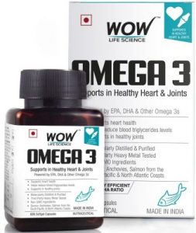

**Features (Per Serving):**

* **Omega Strength:**1000mg
  + **EPA:**550mg
  + **DHA:**350mg
* **Available Sizes:**60 capsules
* **Overall Score:**4.9/5

WOW, Omega-3 Capsules is one of the best fish oil capsules in the Indian market. WOW has been manufacturing health and skincare products since 2013. It is one of the leading brands in India when it comes to the grooming, health, and beauty domain.

Talking about the product, the tablet contains all healthy and adequate omega-3 fatty acids. Each capsule contains 1000mg of omega-3 where 550 mg and 350mg is the EPA and DHA concentration, respectively. The remaining 100mg are accompanied by other omega 3s.

The thing that sets this supplement apart from others is the potency of the ingredients used, as you get three to four times more omega than other products. The WOW fish oils come from anchovies and salmon, mainly found in North Atlantic Costs and South Pacific. This assures the quality and purity of the product, as these fishes are found in low contamination, as we mentioned before. It’s not just our view, but all reviews and ratings are highly favorable for this supplement.

The best part about this capsule that we loved is the triple strength of Omega-3 that safely meets our daily requirements of Omega3. WOW, fish oil provides all the results that we had anticipated from the product. It effectively paves the way for improved heart health, reduces joint pains, strengthens bones, and augments energy and focus.

While testing the supplement, we found that it was quickly absorbed by the body, and the claims about no fish burps were valid. Thanks to enteric coating, the capsules are easily processed by our body.

Since the pills contain 11 fatty acids, it maintains the cholesterol levels and reduces triglyceride levels. It also provides lubricant to the nervous system and joints. In addition, the capsules are free from mercury, binders, fillers, or additives. They are ultra-pure and perfectly refined to provide maximum results.

The products are NON-GMO, and third-party tested to ensure their effectiveness and safety. The triple strength of omega-3 in this capsule also helps us get healthy and glowing skin, hair, and nails.

**Pros:-**

* Sixty capsules with a health 3:2 EPA to DHA ratio
* Entirely natural, dairy-free, contaminants free, thoroughly purified, and ideal for the keto diet
* Triple strength of Omega3 better than most products out there
* Free from binders, additives, fillers, and refined fish oil
* Enteric coating for better absorption and no fishy burps

**Cons:-**

* It worked well for us!

**Highlights:-**

* No fish taste
* Ultra-refined fish oil
* Ideal for Keto diets
* Three times more omega-3
* Relieves joint pain, stress and improves concentration

1. [**Neuherbs Deep Sea Omega-3 Fish Oil**](https://www.amazon.in/Neuherbs-Deep-Omega-Fish-serving/dp/B07WTBN75M/?tag=akdoc-21)

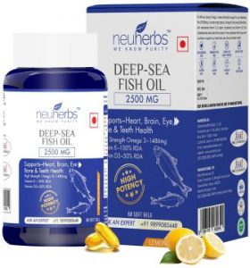

**Features (Per Serving):**

* **Omega Strength:**2500mg
  + **EPA:**892mg
  + **DHA:**594mg
* **Available Sizes:**60 capsules
* **Overall Score:**4.9/5

To compete with our first product, here comes the Neuherbs Deep Sea Omega-3 fish oil, which is the best and ideal supplement for people on a tight budget and who don’t want to compromise on the potency, purity, and palatability of the pills. The company is renowned for its quality and is the best seller on Amazon, so there’s that.

Not only are these capsules highly potent, but they also offer the highest amounts of fatty acids, assuring more excellent health overall. With a shelf life of 24 months, each serving of pills provides 1486 mg of omega-3, where 892mg and 594 mg are the concentration of EPA and DHA.

The capsules also provide 275 mg and 25mg of Linoleic acid (Omega 6) and Oleic acid (Omega 9), respectively, keeping your health at the best and intact. Neuherbs Omega-3 fish oils are also loaded with vitamins E and D3 for healthy functioning of the body while ensuring better skin and bone health.

The included vitamin E also acts as an antioxidant, forestalling the capsule from going rancid or oxidate. There should be no concerns for safety as the brand is certified and all its products are tested and safe to use.

With the 3x omega3 advance formula, the capsules safely fulfill the basic omega3 requirements of our bodies. The added vitamin D3 and vitamin E are 100% RDA and aid in heart and bone health.

We realized that the product uses a lemon flavor to make things more palatable and prevents fishy burps in our testing. The capsules work wonders and take care of their duty to aid the mind, eyes, joints, skin, hair, nail, bones, and heart health while also diminishing inflammation.

Thanks to the reflux-free formula, the capsules get absorbed by our body better. The purity and safety of the product are undeniable. It is free from sugar, sodium, cholesterol, preservatives, and heavy metals, making it safe to consume.

It is ideal for men and women, fitness lovers, and older adults as well. The Neuherbs Omega-3 fish oil serves the body in the best and the most effective way possible. It provides the much-needed mental focus and activeness while dealing with mental stress to improve sleep quality.

Overall we had a good experience using the capsules, and they are easy to swallow and don’t leave any fishy taste behind.

**Pros:-**

* Offers essential amounts of omega3
* Shelf life of 24 months
* Provides Vitamin A and E along with other fatty acids with high potency
* Three-time more strong formula and 2500 mg omega3 strength

**Cons:-**

* The figure mentioned for the supplement is for two capsules, which they did not mention in the description

**Highlights:-**

* Pure, safe, and tested
* Country of Origin India
* A high-strength and potent formula
* No fish burps
* Reflux-free formula and lemon flavor that amounts to the taste

1. [**TrueBasics Omega 3 Fish Oil Capsules**](https://www.amazon.in/TrueBasics-Fish-Ashwagandha-Capsule-Pack/dp/B07XQB87RF/?tag=akdoc-21)

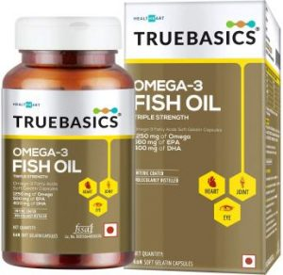

**Features (Per Serving):**

* **Omega Strength:**1250mg
  + **EPA:**560mg
  + **DHA:**400mg
* **Available Sizes:**60 capsules
* **Overall Score:**4.8/5

TrueBasics Omega 3 Fish Oil Capsules are potent, pure, and effective when it comes to delivering these unsaturated fats to our bodies and tissues. They provide a higher concentration of EPA and DHA, thanks to the use of breakthrough extraction.

These capsules have undergone molecular distillation to provide refined and pure omega-3 pills free from heavy metals and other harmful contaminants. The serving size of one tablet is 1.60 g which safely meets the RDA of omega-3 capsules.

With each serving, you get a whopping 1250 mg of omega 3. The EPA takes up 560 mg, and DHA fills another 400 mg gap. The advanced formula with three times strength offers a healthy dose of these polyunsaturated fats much required by our bodies.

These refined omega three capsules are enteric coated that helps to eliminate fishy aftertaste or burps. Additionally, it also aids in better absorption of the fatty acids in our bodies. The fish oil is sourced from cold water fishes such as sardines that reside in low contaminant water and thus ensures the quality of fish oil.

Moreover, the TrueBasics Omega 3 fish oil contains scientifically proven ingredients which are safe and effective to provide fantastic results. The quality is undeniable, and the product is certified by a third party.

Be that as it may, each pill of TrueBasic Omega 3 fish oil contains a higher and adequate concentration of EPA and DHA, which regulates cholesterol levels while providing better heart health. The capsules also maintain the joints’ flexibility and mobility for both men and women by reducing inflammation and joint pains.

The included higher potency and amount of DHA helps to improve brain function and boost memory while also improving vision and cognitive abilities. As for our experience, we had a great time using the pills with [multivitamins](https://doclists.in/best-multivitamin-tablets/).

It works excellent with workout and routine life, leaving us fresh and attentive.

**Pros:-**

* Anti-reflux formula
* Attractive price
* Three-time more omega3
* Advance potent formula with no fishy burps
* Enteric-coated

**Cons:-**

* A bit bulky pills and hard to swallow

**Highlights:-**

* Good quality and certified
* Refined by molecular distillation to remove contaminants
* Scientifically studied and provided ingredients
* Natural and no added flavor or additives

1. [**HealthKart Omega 3**](https://www.amazon.in/HealthKart-Fish-1000-Omega-Capsules/dp/B071LMW6SZ/?tag=akdoc-21)

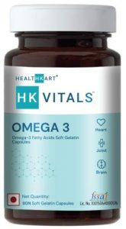

**Features (Per Serving):**

* **Omega Strength:**1000mg
  + **EPA:**180mg
  + **DHA:**120mg
* **Available Sizes:**90 capsules
* **Overall Score:**4.7/5

HealthKart Omega 3 soft gel capsules carry a top-notch caliber of essential acids with the intensity of duplex. You get 1000 mg omega 3, 180 mg, and 120 mg of EPA and DHA individually with each serving. The whole capsules are built by adding premium quality fish oil to them, removing quality and safety concerns.

Talking about the product, these pills are super unadulterated and fully refined through molecular distillation removing all the heavy metals and contaminants such as mercury making them more safe and secure to use and consume.

Thanks to the anti-reflux formula, it rules out the persistent flavors or fishy aftertaste. The capsules offer immense help to the joints ensuring better flexibility and mobility. Of course, they additionally play an imperative role in improving heart and eye health while providing benefits to cognitive functioning.

We loved the product as it is NON-GMO, gluten-free, and manufactured using current good manufacturing practices. The brand and its products are also certified by FSSAI and ISO. Plus, the capsules are pocket-friendly, making them the best bang for your buck.

Not to mention, you get more quantity, around 90 capsules which is higher than most competitors out there, especially at such an attractive price.

**Pros:-**

* Potent and effective capsules
* NON-GMO and CMP certified
* High-caliber EPA and DHA concentration
* Extracted from cold fishes found in Antarctica Sea

**Cons:-**

* Low amount of EPA and DHA

**Highlights:-**

* Gluten-free and quality tested
* Anti-reflux and advance formula for perfect absorption
* Quality marine-based omega3
* FSSAI and GMP certified

1. [**Naturyz Triple Strength Omega 3 Fish Oil**](https://www.amazon.in/Naturyz-Advanced-Multivitamin-Supplement-T-Shirt/dp/B07CCN2291/?tag=akdoc-21)

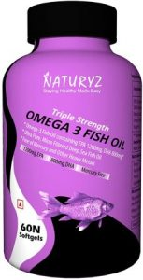

**Features (Per Serving):**

* **Omega Strength:**1000mg
  + **EPA:**600mg
  + **DHA:**400mg
* **Available Sizes:**60 capsules
* **Overall Score:**4.6/5

Coming up next is Naturyz Triple Strength Omega 3 Fish Oil. Though the company is not so familiar in India, the products dominate the popular ones in potency, purity, and quality. Generally, most capsules provide about 300 to 200 mg of EPA and DHA, respectively. However, that’s not the case with the Naturyz Omega 3 supplement which offers 1400mg of fish oil and 600 and 400 mg of EPA and DHA in one serving.

The thing that we loved about this product while trying it out was the filtration and purity it offers. Extracted from small cold-water fishes, this product goes through seven stages of filtration. That is the highest amount, making sure a better immune system and body health.

The capsules get micro-filtered, undergo molecular distillation, and later are received free from mercury and other harmful toxins. By just consuming one capsule a day, our body receives more than three times of omega3 in a safe dose.

The capsules are ultra-pure and offer many health benefits; the biggest one is supreme joint support and improves the brain’s functioning and overall attentiveness. Furthermore, to ensure that you receive the highest quality product, all the company’s products undergo rigorous quality checks.

Another good thing about Naturyz Omega3 fish oil is the premium absorption design. The pills are intended for easy consumption and absorption of the fats in our bodies. Besides that, they are also approved by ISO, FSSAI, HACCP, and GMP to ensure the safety and effectiveness of the capsules.

Since they are rich in DHA and EPA, the pills also boost immunity and reduce inflammation in our bodies. Not just that, but the capsules also provide 350mg and 100 mg of Omega 6 and Omega 9 per two servings.

**Pros:-**

* Rich in Omega 3, 6, and 9 with a three times potent formula
* Best bang for the buck
* Quality tested and certified product
* Easy to consume and processed by the body

**Cons:-**

* No antioxidant to stabilize the formula

**Highlights:-**

* Three times normal omega 3
* Cost-effective
* GMP, ISO, FSSAI, and HACCP certified
* Ultra-pure, micro-filtered, and free from contaminants

1. [**Carbamide Forte Triple Strength Omega 3 Fish Oil Capsules**](https://www.amazon.in/Carbamide-Forte-1400mg-capsule-Strength/dp/B07S184VRN/?tag=akdoc-21)

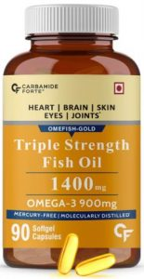

**Features (Per Serving):**

* **Omega Strength:**1400mg
  + **EPA:**495mg
  + **DHA:**330mg
* **Available Sizes:**90 capsules
* **Overall Score:**4.7/5

Is it true that you are as yet swallowing 5 to 6 capsules to get your everyday standard of omega3? Carbamide Forte is potent with three-times strength superior grade omega3 fish oil. That provides 495 mg and 330mg of EPA and DHA, respectively, while the remaining 75 mg are occupied by other essential fatty acids.

You get the benefits of three capsules in only one with the help of this 3x potent advance formula. The pills are easy to process and absorb while cutting out the fishy aftertaste, making them more reliable and convenient.

Carbamide Forte fish oil supplement undergoes maximum filtration and subatomic definition, removing heavy metals, PCBs, and other harmful toxins from the capsule while keeping it clean and safe to consume.

As for the potency of the product, it is immaculate. The capsules are rich in EPA and DHA, and they are available in triglyceride (TG) form known for faster and better absorption out of all types of omega3 forms.

Each capsule is loaded with rich yet premium quality fish oil extracted from cold water fishes naturally less in contaminants. The advanced formula is highly concentrated and potent, providing maxim results and support for health, heart, mind, and eye.

Thanks to the triple strength of highly concentrated fish oil, it effectively strengthens hair, improves brain health, strengthens bones, reduces joint pain, and glows skin. It also improves the health of blood vessels and lowers blood pressure.

The product is certified from ISO, GMP, FSSAI and free from mercury, harmful toxins, additives, preservatives, and parabens.

**Pros:-**

* 3x fish oil for heart, joints, skin, eyes, and brain
* A highly concentrated and potent formula
* Available in triglyceride form
* Fully refined and awesome purity

**Cons:-**

* A little big and hard to swallow capsules

**Highlights:-**

* Burpless with lemon flavor that amounts to the taste
* Molecularly distilled and mercury-free
* You get 90 capsules
* Safe and potent concentration of EPA and DHA

**DROPS**

**1.**[**JUNEJA’S EYE MANTRA AYURVEDIC EYEDROPS**](https://amzn.to/2SUJYJA)

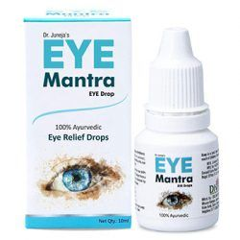

* Dr. Juneja’s Eye Mantra is an Ayurvedic Eye Drops available in 10ml Pack at the nearest Pharmacy, or either you can purchase it online. Natural ingredients such as Neem, Honey, Tusli, Rosa, Turmeric, Daruhaldi, and Punarnava makes this Ayurvedic Eye Drop Suitable for Regular use.

Working from home is the brand new way of getting things done, and continuous work on Computers and tablets makes eyes itchy and tired, Dr. Juneja’s Eve Mantra Ayurvedic Eye Drop helps in soothing dry, Itchy, and tired eyes. This eye drop is also useful in allergies related to eyes. This eye drop is selling at one of the top ranks in the Eye Drops section at Amazon India and secure Best-Selling Rank 4.

**Pros**

* Pocket Friendly Ayurvedic eye drop with all-natural ingredients.
* Sufficient eye drop, which is suitable for daily uses without having any side effects.
* This eye drop relaxes eyes in every aspect.

**Cons**

* The only con of this Eye drop is that it burns when you use it for the first time.

**2.**[**ISOTINE EYE DROP**](https://amzn.to/3iSEc5L)

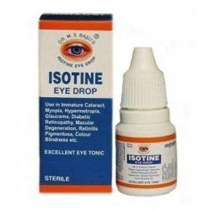

* Isotine Plus increases EyeSight naturally with no side effects and helps in removing spectacles. Manufacturers also claimed that This eye drop is also helpful in Myopia, Hypermetropia, Colour Blindness, Macular Degeneration, Immature Cataract, Glaucoma, Retinitis Pigmentation, etc.

Regular use (2 drops, three times a day) of this Eye drop for two to three months improves vision immediately. Readily Available at almost every Pharmaceutical store and online platforms, available in 10ml Pack, this eye drop is also helpful in soothing the dry and tired eyes.

Vocal for Local is the latest revolution going on across the country. This eye drop is solemnly Indian local product available with beneficial results and at very cheap rates.

**Pros**

* A reliable and effective product, registered and patented by the Government of India.
* It Improves Eye vision and eyesight, Pocket friendly.
* This is a Made in India Product and therefore, supports the made in India initiative of the Government of India.

**Cons**

* Manufacturers claim more than the actual effect of this eye drop which might lead to less satisfactory results as the buyers have high expectations.

**3.**[**AL-SHAMS EYE DROPS**](https://amzn.to/3nS5yNo)

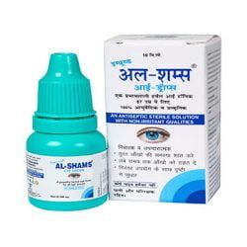

* An ayurvedic and herbal eye drop that works wonders about protecting your eyes from adverse environmental conditions, heat, dust, smoke, humidity, pollution, dryness, puffiness, tiredness, and high exposure to fast-moving digital life.

This product comes with a guarantee of no side-effects on usage. It is made using a 100% plant-based formula and naturally occurring minerals to support healthy and sharp eyes. It also helps in dealing with issues such as pink eyes, cataract delays, chronic and acute eye allergies, haziness in eyes, etc. Besides, this eye drop is non-irritant, unlike the other substitutes available in the market that cause an irritating and itchy sensation on the first-time usage.

**Pros**

* Guaranteed No side-effect formula.
* Helps in dealing with stress and strain caused in eyes due to regular use of contact lenses.
* This eye drop could be used without any problems just to promote healthy and sharp eyes.

**Cons**

* This product has to be used repeatedly after every one or two hours. This makes it impractical and impossible for usage by people who do not stay at home or are continuously traveling.

**4.**[**GENERIC RW CINERARIA MARTIMA**](https://amzn.to/312MamO)

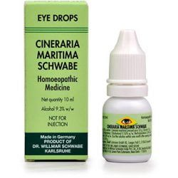

* This is an eye drop made with the help of chemicals that are beneficial for promoting healthy eyes. This eye drop is instrumental in curing allergic reactions and other medical problems with the eyes. It is the second-best-selling eye drop in the online Indian market. This eye drop is next to perfect for your eyes.

The primary ingredient used for producing this eye drop is Senecio bicolor D2. It is a product made in Germany using extremely advanced and high-tech processes.

**Pros**

* Shows fast and instant results only after the first usage.
* This eye drop is beneficial for curing eye infections that might be caused due to fungus, bacteria, or other harmful exposures.
* This eye drop is exceptionally affordable and good for your eyes. You could use it over a regular period.

**Cons**

* Since this eye drop is made using stable chemically produced compounds, it might result in certain side-effects over an elongated usage.

**5.**[**HIMALAYA OPTHA CARE**](https://amzn.to/2SUL6Nj)

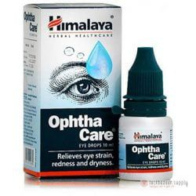

* Himalaya optha care is one of the best eye drops that are available in the Indian markets. This eye drop is known mostly for the cooling effect that it introduces in the eyes after the first drop itself. This eye drop is hugely effective in comforting your eyes after a big and hectic day.

This product has potent properties that are great for killing the harmful bacteria that cause infections and other problems in your eyes. It also has antihistaminic features that make it one of the best eye drops for combating diseases and allergies. When used after a whole day of working on computer screens, this eye drop produces a different type of soothing and comforting effect on your eyes that will promote good sleep.

**Pros**

* This product has no side effects; therefore, it could be used regularly to provide comfort to your eyes.
* It is reliable and can be afforded easily due to its cheap rates.
* This product is suitable for people who have allergies or infections in their eyes due to external factors.

**Cons**

* The product might cause a blurred vision and feel lime dust particles on the first us

**FITNESS PRODUCTS**

## Creatine

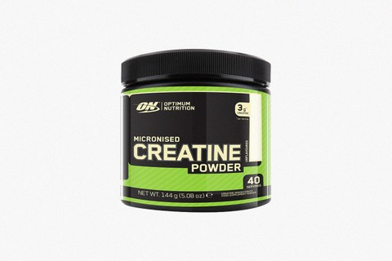

When it comes to the whole “magic pill” aspect of workout supplements, creatine is about as close as it gets without being a load of bullshit. Creatine is a naturally occurring nitrogenous organic acid that occurs in all of us. In its synthesized form, creatine is a performance-enhancing substance that helps boost the production of adenosine triphosphate (ATP), which helps in muscle repair and growth under stress.

Essentially, creatine gives bursts of energy and helps with muscle repair during your workout, to help you run a little faster, put up one or two more reps, and push your muscles to perform their best. People have conducted literally hundreds of clinical studies on the stuff, and while results definitely vary from person to person and study to study, the facts are clear: this stuff works.

It comes in a lot of forms; powder, liquid, solids, etc. It’s also found in smaller doses in things like meat, fish, and eggs, but it’s obviously better and more useful in a concentrated powder.

## Branched Chain Amino Acids (BCAAs)

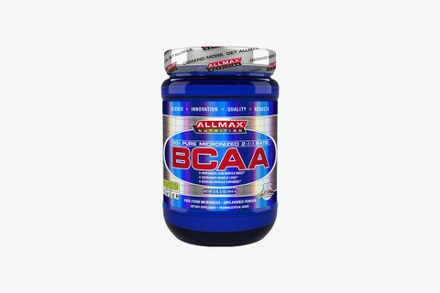

BCAAs are awesome because they don’t just help you during your workout, but also after. In fact, they shine brightest in the post-workout stages. BCAAs are a mix of three vital amino acids – leucine, isoleucine and valine – that are essential to muscle repair and recovery. Their whole job is to help your muscles recover faster after a hard workout, which means you spend less days off from being sore and feeling beat to shit, and more time in the gym putting up the heavy stuff.

It even goes a lot deeper than that. Aside from helping muscles repair themselves, these amino acids also help provide much-needed energy in the gym, but also curb the production of certain hormones that actually work against your body’s attempts to build muscles – most notably, cortisol.

The trick about BCAAs is that you really have to remember to keep taking them throughout the day. Literally, you have to be eating these things in the morning, at night, before, during and after your workout, etc., in order to get the best results from them. Luckily, BCAA powders aren’t necessarily that pricey, so keeping them in your diet won’t be too hard on your wallet.

## Fish Oil

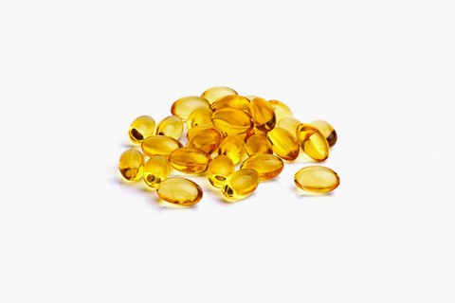

I don’t really understand why, but it seems the more people I talk to about fish oil and its benefits, the more people I encounter who don’t really see it as necessary. The truth is, fish oil isn’t snake oil, and its benefits are absolutely real.

Fish oil contains a super high amount of Omega 3 oils, which is a natural anti-inflammatory that can really mean the difference between running a mile or being able to lay down five. It will help ease joint and muscle soreness, and is vital to the recovery process.

Hell, even if you’re not in the gym or training for that half marathon you’ve been eyeing up, fish oil is excellent for your lungs, blood circulation and heart health.

The largest issue people have is finding a reputable brand that isn’t cut with a bunch of other useless ingredients, but they’re definitely [out there](https://go.hsnob.co/?u=https%3A%2F%2Fwww.amazon.com%2FDr-Tobias-Strength-Burpless-NSF-Certified%2Fdp%2FB00CAZAU62%2Fref%3Dsr_1_5_s_it%3Fs%3Dhpc%26amp%3Bie%3DUTF8%26amp%3Bqid%3D1498798097%26amp%3Bsr%3D1-5%26amp%3Bkeywords%3DFish%252Boil%26amp%3Bth%3D1%23customerReviews&cp=1418572&r=unknown&cme=amp&cmo=text_link). Any way you slice it, this stuff is critical to your workout regimen.

## Beta-Alanine

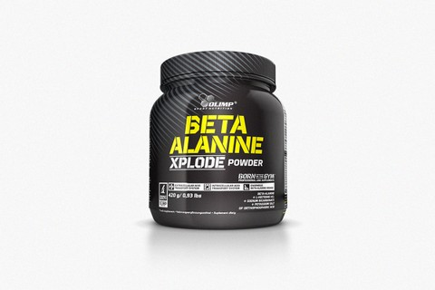

Probably the least well-known supplement on this list, beta-alanine is another natural amino acid that helps to drastically reduce muscle fatigue by boosting your body’s level of carnosine. Carnosine works in your body to prevent the build up of acids, thereby reducing muscle strain, fatigue and corrosion.

The problem is, your body only has so much carnosine, and it can only produce as much carnosine as you have beta-alanine. So, by taking concentrated amounts of beta-alanine, you’re allowing your body extra room to produce more carnosine, and therefore more resistance against fatigue.

The other problem with beta-alanine is that, like BCAAs, you really have to stay on top of your shit. [Research](https://go.hsnob.co/?u=https%3A%2F%2Fwww.ncbi.nlm.nih.gov%2Fpmc%2Farticles%2FPMC3257613%2F&cp=1418572&r=unknown&cme=amp&cmo=text_link) from a team at Texas A&M noted that taking 800mg of beta-alanine a day helped boost carnosine levels by 66 percent. The only problem is that you have to take that dosage upwards of four times a day. It can get overwhelming, to say the least.

But if you stick to it and make sure you’re ingesting the appropriate dosage, the results are undeniable.

## Carbohydrates

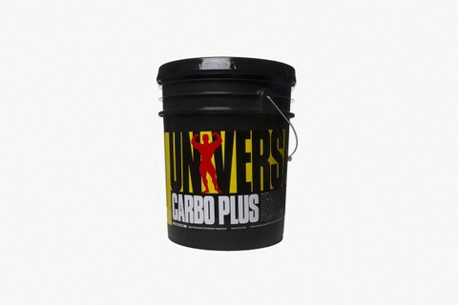

You’re confused right now, because for as long as you’ve been dieting and working out, people have told you that carbs are the enemy. If all you’re worried about is cutting fat and losing weight, that might be true. But if you’re trying to pack on muscle and keep burning fat long after the workout is over, you should be ingesting simple carbohydrates twice a day: once as soon as you wake up, and once right after a workout.

The rationale there is that once your workout is over, your body’s glycogen and glucose levels are completely trashed. Once that happens, your body secretes that cortisol stuff I talked about above, and begins eating away at all that valuable muscle you just spent time and energy making. Ingesting simple carbs (sugars) helps raise your body’s glucose level, prevents cortisol from being secreted, and helps save that muscle tissue you’re working so hard to pack on.

Carbohydrates in the form of supplements helps cut out all the extra crap that you’d normally get from ingesting it in food. You could eat a bunch of simple carbs in different foods, but having a supplement helps regulate your carb intake perfectly, giving you everything you need to keep that muscle where it belongs.